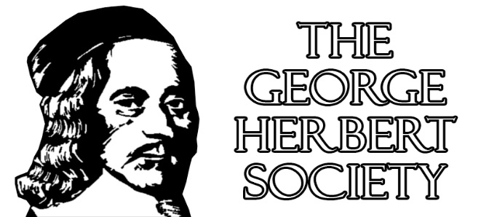
announces
The Sixth Triennial Conference
at Cambridge University
George Herbert and Eloquence
17-20 June 2021
In partnership with
Clare College, Little St Mary’s Church, Magdalene College, and Girton College
Plenary Speakers: Sidney Gottlieb, Sacred Heart University
Malcolm Guite, Girton College, Retired
Helen Wilcox, Bangor University, Wales
Rowan Williams, Archbishop Emeritus of Canterbury
Supplementary Call for Papers
Since the announced rescheduling of our conference required by the worldwide Coronavirus crisis, the Conference Organisers have been heartened by the enthusiastic recommitment of most conference delegates to the new dates of 17-20 June 2021. However, some delegates have inevitably been forced to withdraw, leaving a limited number of openings in the programme. We announce the following Supplementary Call for Papers, similar in theme to the previous Call, but with a few particularly timely categories suggested.
In 1620 George Herbert was elected Public Orator of Cambridge University, an office that he had eagerly sought and recently described to his stepfather Sir John Danvers as ‘the finest place in the University … for the Orator writes all the University Letters, makes all the Orations, be it to King, Prince … he takes place next the Doctors, is at all their Assemblies and Meetings, and sits above the Proctors, … and such like Gaynesses, which will please a young man well’. And yet within a decade a not-so-young Herbert would write ‘The Quip’, mocking the cold comfort of eloquence, of ‘quick Wit and Conversation’ who, ‘to be short, make an Oration. / But thou shalt answer, Lord, for me’.
Four hundred (and one) years after Herbert’s election to the Oratorship, the George Herbert Society will meet at Cambridge to consider Herbert’s notoriously complex relationship with eloquence, rhetoric, and ornament. Gathering at four sites—Clare College, Little St Mary’s Church, Magdalene College, and Girton College—our conference encourages papers and whole panels that will examine Herbert’s achievements in the verbal arts, as well as their often disruptive (and frequently deliberate) unsuccess. We seek proposals from both established scholars in the field as well as independent scholars, newcomers to the George Herbert Society, and especially graduate students.
Though we welcome proposals in all areas of Herbert studies, we particularly seek those focusing on Herbert’s oratory, his Latin and English styles, his principles of preaching, the embedded speeches and sermons in his poetry—as well as on the hierarchical finery and leveling plainness often at odds in his work. We also encourage work on the following Cambridge-related topics: Herbert’s surviving and/or lost orations; his lover’s quarrel with worldly place and power; the relationship between the stratified social order of early Stuart Cambridge and the oratorical culture of compliment and patronage; classical and/vs. biblical eloquence; Latin and/vs. English eloquence; syntactic and/vs. paratactic style; Herbertian self-fashioning revisited; the poetics of unsuccess; and Herbert’s Solomonic persona—from prudential wisdom and public eloquence to critique of their vanity. Other more particularly local and historical topics of interest may include: Herbert’s Cambridge correspondence; Herbert and Sir Francis Nethersole; Herbert’s campaign for the Oratorship; the Orator’s office and career advancement; Herbert, King James I, and Prince Charles/King Charles I; Herbert and the Spanish Match; Herbert and Leighton Bromswold; Herbert, Ferrar, and Little Gidding; Herbert and the Cambridge Puritans of Massachusetts Bay. Other connections to specific colleges and churches: Clare—Herbert and Latimer; Herbert and Ferrar; Little St Mary’s—Herbert and Crashaw; Herbert and Thomas Campion. Trinity—Herbert’s Trinity College years; Herbert and Bacon; Herbert and Marvell. Magdalene—Herbert and Cranmer; William Empson’s Seven Types of Ambiguity revisited; Herbert and C. S. Lewis. Girton: Herbert and Malcolm Guite. Christ’s—Herbert and William Perkins; Herbert and Milton; Herbert and Rowan Williams. Emmanuel—Herbert and John Harvard. We also would welcome paper and panel submissions considering how we teach Herbert in times of plague and protest; and regarding the work and legacies of GHS co-founder Elizabeth Clarke, and of late Herbertians Daniel Doerksen, Cristina Malcolmson, and Chauncey Wood.
Abstracts in English of no more than 300 words accompanied by a brief CV should be sent to the conference organizers at herbconf@uncg.edu, by November 15, 2020. Early submissions are welcome!
Notifications of acceptance: January 15, 2021.
Anyone may submit an abstract, but only current 2020-21 GHS members may deliver a paper.
Information regarding accommodation and registration will continue through fall and winter 2020-21. For ongoing updates, see https://english.uncg.edu/george_herbert/
Conference Organisers:
Christopher Hodgkins (University of North Carolina-Greensboro, Director, George Herbert Society); Adele Davidson (Kenyon College); Sidney Gottlieb (Sacred Heart University); Kenneth Graham (University of Waterloo); Malcolm Guite (Girton College, Cambridge, Retired); Simon Jackson (Peterhouse, Cambridge); Michael C. Schoenfeldt (University of Michigan-Ann Arbor); Anne Myers (University of Missouri-Columbia); Helen Wilcox (Bangor University); Rowan Williams (Archbishop Emeritus of Canterbury)

Note: In the event of future COVID or similar crises in 2021: This conference will meet at these places on these dates unless governmental or institutional policy makes it impossible—or unless further developments make it unwise—to do so; in such cases, GHS will make plans to offer the conference online, with consideration for registration rollovers, cancellations and refunds.

