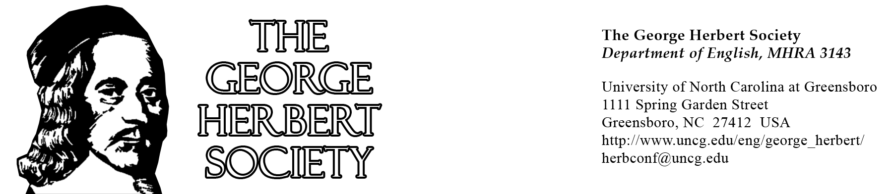
Announces Registration for the Sixth Triennial Conference
at
Cambridge University

George Herbert and Eloquence
18-21 June 2020
In partnership with
Peterhouse College, Trinity College, Magdalene College, and Girton College
Plenary Speakers: Sidney Gottlieb, Sacred Heart University
Malcolm Guite, Girton College
Helen Wilcox, Bangor University, Wales
Rowan Williams, Master of Magdalene College

Dear Herbert in Cambridge Participants,

We are happy to announce the new registration link for the Fifth Triennial Conference of the George Herbert Society, ‘George Herbert and Eloquence’. Registration is payable directly online at the following new link:

https://www.nexternal.com/uncg/herbert-in-cambridge-sixth-triennial-international-conference-of-the-george-herbert-society-p2966.aspx

You can choose from the following combinations:
-a registration only flat fee (faculty: $140 US/ students, retired, and clergy: $40 US)
-a registration + Friday 19 June Trinity College gala dinner fee ($185 US / $85 US)
-a registration + Sunday 21 June Girton College box lunch fee ($160 US / $60 US)
-full registration, including the gala dinner and Sunday lunch ($205 US / $105 US)

At the Portal, please choose from the menu options: Faculty or Student/Retired/Clergy/ Spouse; and for the extra meals, also indicating any dietary restrictions.

Please note that you must be a current George Herbert Society member for 2019-2020 in order to register at the conference. Dues are payable online at: https://english.uncg.edu/george-herbert-society/information-and-dues-structure/

We are assembling a full four-day programme (to be announced in the new year): the conference will begin on Thursday 18 June 2020 at 8:30 a.m. and will run through the evening of Sunday 21 June, each day at a successive college: Peterhouse, Trinity, Magdalene, Girton. On Sunday afternoon, a coach outing to Leighton Bromswold and Little Gidding is scheduled (with a return to Cambridge around 6 pm). In addition, throughout the conference, the Keeper of the Cambridge University Archives will mount a ‘pop-up’ exhibition of Herbert-related materials in its collection, including a newly identified letter in Herbert’s own hand from his Cambridge years.
Registration includes all plenaries and panels, two concerts (choral and folk-rock), two poetry readings, historical walks in the sponsoring colleges, visits to the University Archives, an optional Sunday eucharist, the coach ride to Leighton Bromswold and Little Gidding on Sunday, two drinks receptions, and generous refreshments throughout—all are included in the flat registration fee. The only two optional meals for which there are additional costs are the Friday evening gala dinner at Trinity and the Sunday box lunch at Girton. As Cambridge is choc-a-bloc with delightful restaurants, pubs, and eateries, we’ll leave you plenty of opportunities to forage happily on your own for many meals.

Cambridge also affords a wide range of lodging options, from budget hostels and modest motels to cosy b&b’s and finer hotels, many within walking distance of the old colleges. Attached please find a list of lodging possibilities. If you need any help finding accommodation, please let us know.

Modest GHS travel bursaries are available, upon application, for students and independent scholars. For details, please see https://english.uncg.edu/george-herbert-society/ghs-fund-application-instructions/

We very much look forward to welcoming you to Cambridge in June, truly the loveliest and longest days of the year!

All best,
Christopher Hodgkins, for the organising committee

